6 Uses for static electricity:


1: Pollution control:
They use static electricity to charge the dirty particles in the air and then collect the charged particles on a plate or collector of the opposite electrical charge.
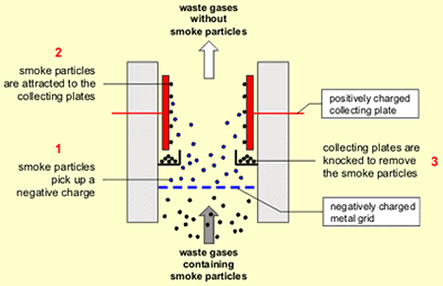
2: Smokestacks:
It uses the same principal to the pollution control factories use this in their chimneys on a bigger scale.

3: Xeography:
On photocopiers we use static electricity to make the inc stick to the paper, another version uses static electricity to make ink stick to a drum which then transfers it to the paper.

4: Painting cars:
We charge the paint with static electricity which makes it easier to stick to the frame.
The paint will also get distributed with better ease.

